 | 12.1.23 Editors - Geometry Nodes Editor - Header - Add Menu - Mesh - Sample
Table of content
Detailed table of content 1
Add menu - Mesh - Sample 2
Sample Nearest Surface 2
Sample UV Surface 3

Detailed table of content
Detailed table of content
Detailed table of content 1
Add menu - Mesh - Sample 2
Sample Nearest Surface 2
Inputs 2
Mesh 2
Value 2
Group ID 2
Sample Position 2
Sample Group ID 2
Properties 2
Data Type 2
Outputs 2
Value 2
Is Valid 2
Sample UV Surface 3
Inputs 3
Mesh 3
Value 3
Source UV Map 3
Sample UV 3
Properties 3
Data Type 3
Outputs 3
Value 3
Is Valid 3

Add menu - Mesh - Sample
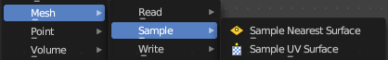
Nodes to modify the mesh geometry.

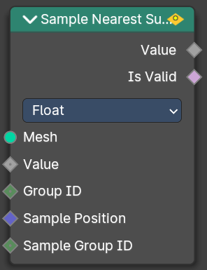
Sample Nearest Surface
Calculate the interpolated value of a mesh attribute on the closest point of its surface.

Inputs

Mesh
Input mesh.

Value
The value to calculate.

Group ID
Is evaluated on the face domain, and splits the input mesh into multiple parts, each with its own id.

Sample Position
The sample position to calculate.

Sample Group ID
Determines in which group the closest nearest surface is detected.

Properties

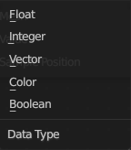
Data Type
Which data to calculate.

Outputs

Value
The output value.

Is Valid
Wether the sampling was successful. It is false when the sampled group is empty.

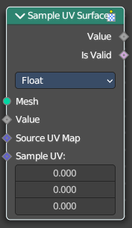
Sample UV Surface
Calculate the interpolated value of a mesh attribute at a UV coordinate.

Inputs

Mesh
Input mesh.

Value
The value to calculate.

Source UV Map
The input UV map.

Sample UV
The sample position to calculate.

Properties

Data Type
Which data to calculate.

Outputs

Value
The output value.

Is Valid
Wether the node could find a single face to sample at the uv coordinate.

